Day 14 CREATE ALL CONNECTION FRONTEND TO BACKEND USING MIDDDLEWARE

**USING ROUER CRETAE 3 COMPONENTS :**

**1)Createuser**

import React,{useState} from 'react'

import axios from 'axios';

const Createuser = () => {

const [name,setName]=useState("");

const [email,setEmail]=useState("");

const [age,setAge]=useState(0);

function handleSubmit(event){

event.preventDefault();

console.log(name,email,age);

axios.post("http://localhost:4000/Create_User",{name,age,email}).then((response)=>{

console.log(response)})

.catch(err=>{console.log(err)})

}

return (

<div>

<form className='Create_user_form' >

<label>Enter Name:</label>

<input placeholder="Enter your Name" value={name} type="text" onChange={(e)=>setName(e.target.value)}/>

<br/>

<label>Enter Age:</label>

<input placeholder="Enter your Age" value={age} type="number" onChange={(e)=>setAge(e.target.value)}/>

<br/>

<label>Enter Email:</label>

<input placeholder="Enter your Email" value={email} type="email" onChange={(e)=>setEmail(e.target.value)}/>

<br/>

<button type="submit" onClick={handleSubmit}>Submit</button>

</form>

<p>Name:{name}</p>

<p>Age:{age}</p>

<p>Email:{email}</p>

</div>

)

}

export default Createuser

**2) User.JS**

import React from 'react'

export const User = () => {

  return (

    <div>User</div>

  )

}

**3) Updateuser.js**

import React from 'react'

export const Updateuser = () => {

  return (

    <div>Updateuser</div>

  )

}

**Final App.js**

import logo from './logo.svg';

import './App.css';

import {User} from './User';

import { Updateuser } from './Updateuser';

import Createuser from './Createuser';

import { BrowserRouter, Route, Routes, Link } from 'react-router-dom';

import { Emp1 } from './emp1';

function App() {

return (

<div className="App">

<BrowserRouter>

<nav className="navbar">

<Link to="/User">User</Link>

<Link to="/Updateuser">Updateuser</Link>

<Link to="/Createuser">Createuser</Link>

< Link to="/emp1">EmployeeDetails</Link>

</nav>

<Routes>

<Route path="/User" element={<User />} />

<Route path="/Createuser" element={<Createuser />} />

<Route path="/Updateuser" element={<Updateuser />} />

<Route path="/emp1" element={<Emp1 />} />

</Routes>

</BrowserRouter>

</div>

);

}

export default App;

**INSIDE MONOGOCRUD CREATE SERVER FOLDER THERE CREATE SERVER.JS   
FOR 2 ND TASK CREATE MODELS FOLDER INSIDE SERVER FOLDER ,THERE MODELS INSIDE Users.js**

**MODELS->USERS.JS**

const mongoose=require('mongoose')

const UserSchema=new mongoose.Schema({

    name:String,

    age:Number,

    email:String

})

const UserSchema1=new mongoose.Schema({

    ID:String,

    name:String,

    Salary:Number,

    contact:Array

})

const UserModel=mongoose.model("users",UserSchema)

const UserModel1=mongoose.model("dhoona",UserSchema1)

module.exports={UserModel,UserModel1}

SERVER->SERVER.JS

const express = require('express');

const cors = require('cors');

const mongoose = require('mongoose');

const { UserModel, UserModel1 } = require('./models/Users');

mongoose.connect("mongodb://localhost:27017/Crud")

const app = express();

const port = 4000;

// Middleware

app.use(cors());

app.use(express.json());

// Routes

app.post("/Createuser", (req, res) => {

    UserModel.create(req.body)

        .then(user => res.json(user))

        .catch(err => res.status(400).json(err));

});

app.post("/empemp", (req, res) => {

    UserModel1.create(req.body)

        .then(gaya => res.json(gaya))

        .catch(err => res.status(400).json(err));

});

app.listen(port, () => {

    console.log(`Server is running at http://localhost:${port}`);

});

**FOR NEXT TASK EMP1 :**

import React,{useState} from 'react'

import axios from 'axios';

export const Emp1 = () => {

const [ID,setId] = useState('');

const [name,setName]=useState("");

const [Salary,setSalary]=useState("");

const [contact,setContact]=useState([]);

const handleSubmit = (event) => {

event.preventDefault();

const payload = {

ID,

name,

Salary: parseFloat(Salary),

contact: parseInt(contact),

};

axios.post("http://localhost:4000/empemp", payload)

.then((response) => console.log(response))

.catch((err) => console.error(err));

};

return (

<div>

<form >

<label>Enter ID:</label>

<input placeholder="Enter your ID" value={ID} type="text" onChange={(e)=>setId(e.target.value)}/>

<br/>

<label>Enter Name:</label>

<input placeholder="Enter your Name" value={name} type="text" onChange={(e)=>setName(e.target.value)}/>

<br/>

<label>Enter salary :</label>

<input placeholder="Enter your Salary" value={Salary} type="number" onChange={(e)=>setSalary(e.target.value)}/>

<br/>

<label>Enter contact:</label>

<input placeholder="Enter your contact" value={contact} type="array" onChange={(e)=>setContact([e.target.value])}/>

<br/>

<button type="submit" onClick={handleSubmit}>Submit</button>

</form>

<p>Name:{name}</p>

</div>

)

}

OUTPUT:

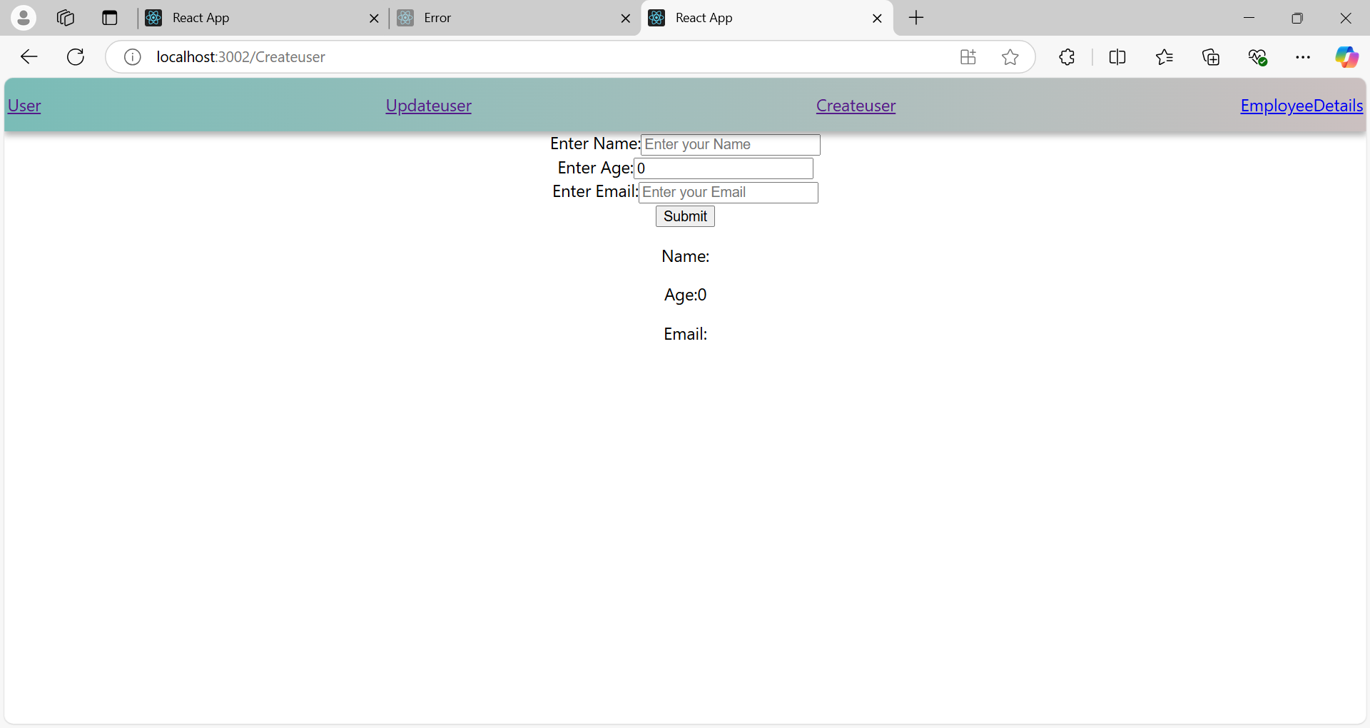

Starting

After input:

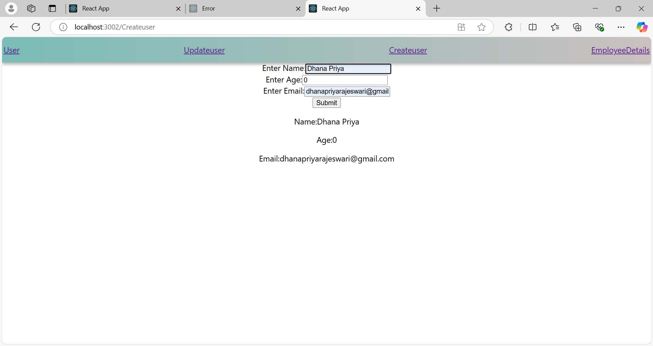

Task 2:

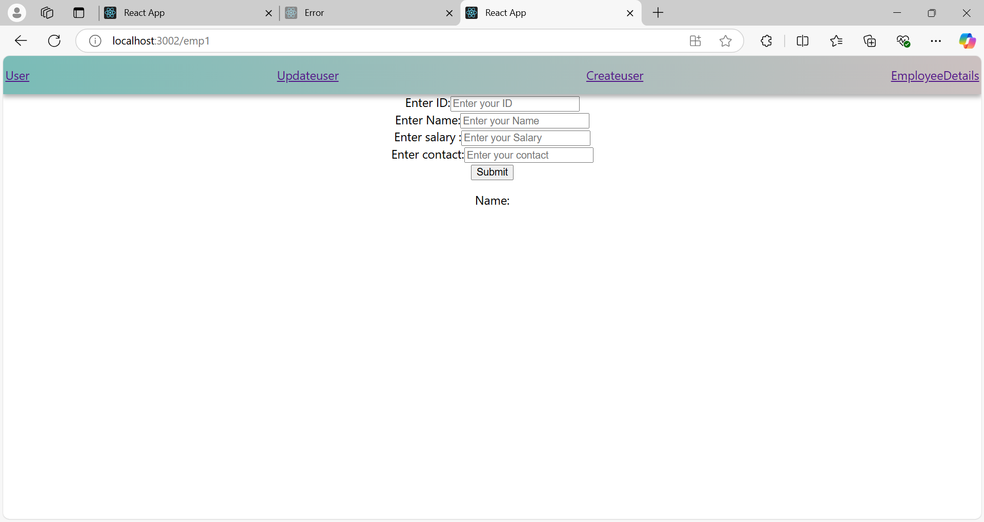

starting

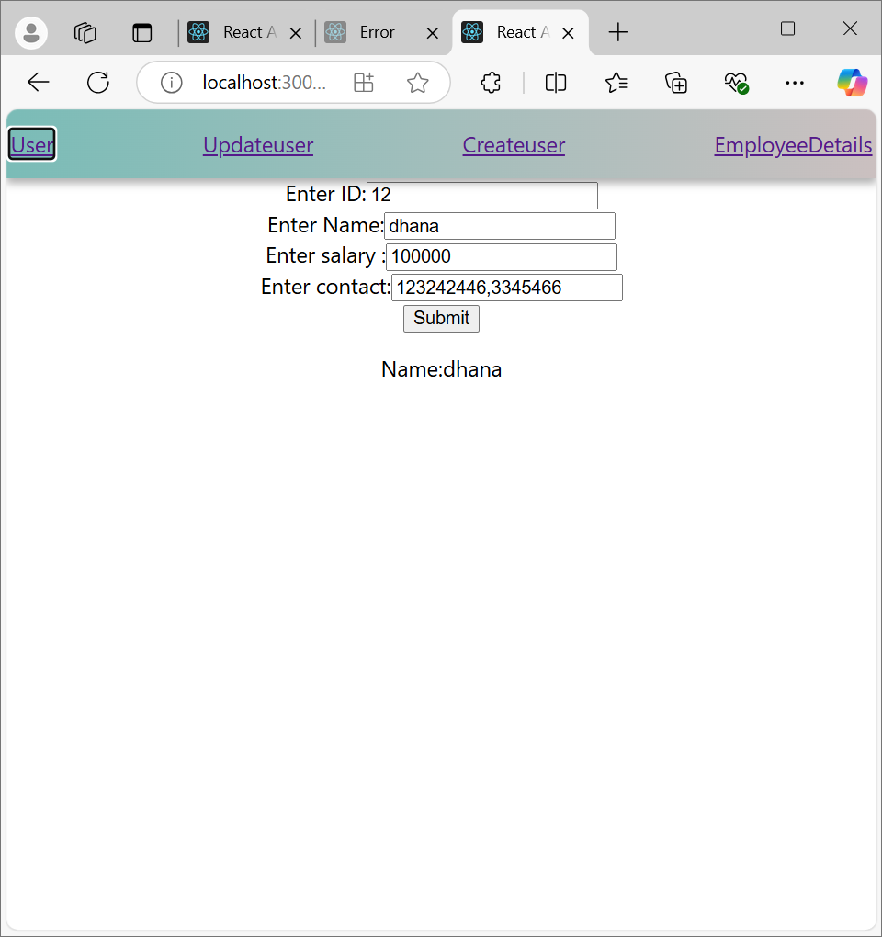

when u click it goes to database:

